

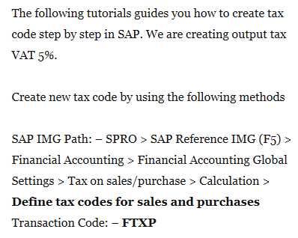

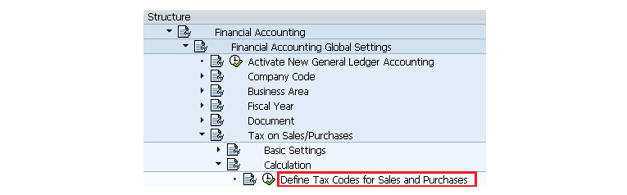

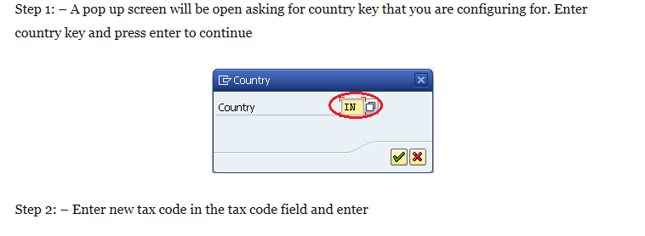

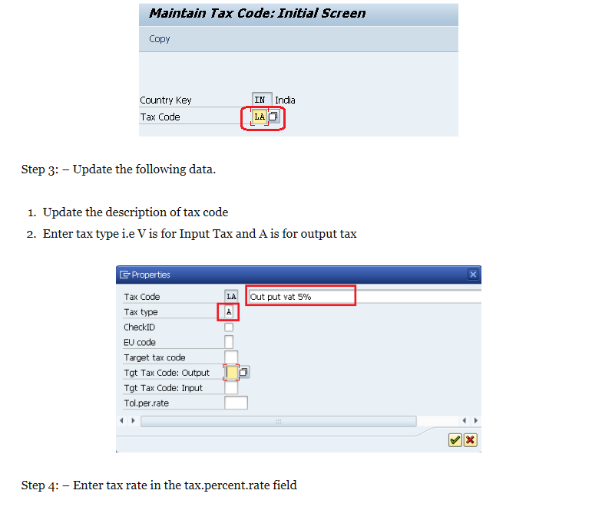

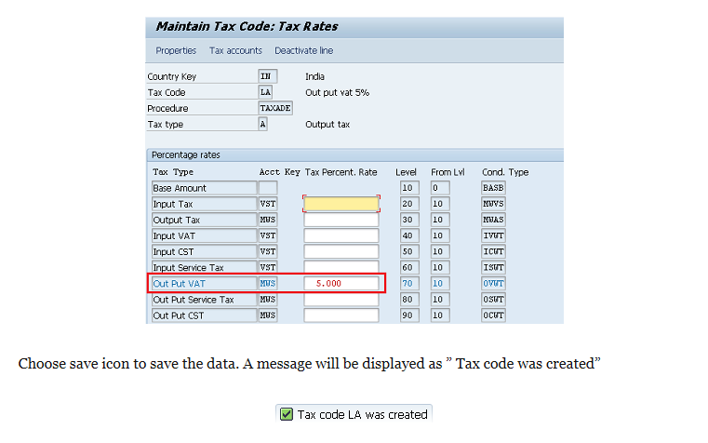

How to Post Withholding Tax during Vendor Invoice Posting

Enter transaction FB60 in SAP Command Field

[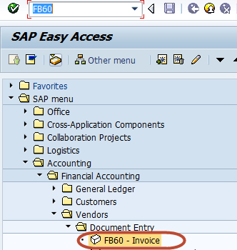](http://cdn.guru99.com/images/sap/2012/07/WithHInv011.png)

In  the Next Screen , Enter Company Code you want to post invoice to

[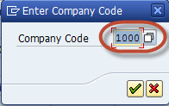](http://cdn.guru99.com/images/sap/2012/05/Custinv023.png)

In the next screen, Enter the Following

1. Enter the Vendor ID (Withholding Tax Enabled )of the Vendor to be Invoiced
2. Enter Invoice Date
3. Check Document Type Vendor Invoice
4. Enter Amount for Invoice
5. Select Tax Code for the Tax Applicable
6. Select Tax Indicator "Calculate Tax".
7. Enter the Purchase Account
8. Enter Amount for the Invoice

[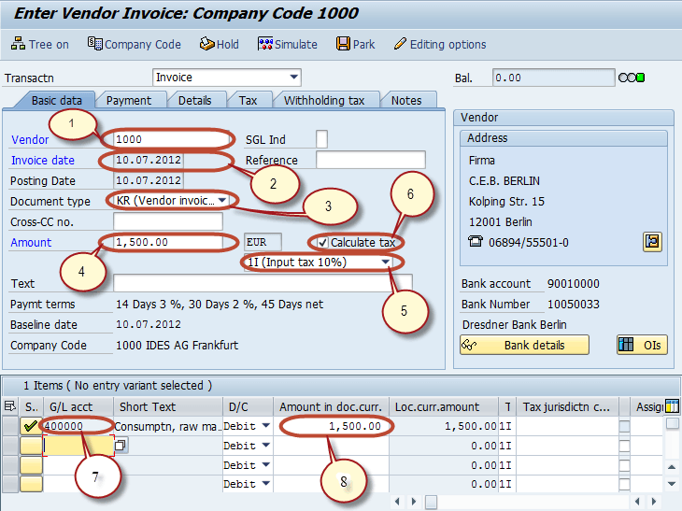](http://cdn.guru99.com/images/sap/2012/07/WithHInv022.png)

After completing the above entries Select the Withholding Tax Tab and Enter the Following

1. Enter the Tax Base Amount
2. Enter the Tax Exempt Amount
3. Check the Withholding Tax Code

[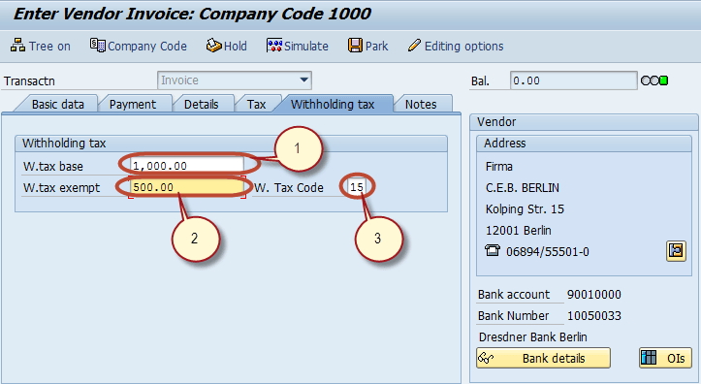](http://cdn.guru99.com/images/sap/2012/07/WithHInv031.png)

    Press Post  Button in Standard bar

[How to Post Withholding Tax during Vendor Invoice Posting](http://cdn.guru99.com/images/sap/2012/07/WithHInv041.png)

And wait for Document number to be generated and display on the status bar for Conformation

[How to Post Withholding Tax during Vendor Invoice Posting](http://cdn.guru99.com/images/sap/2012/07/WithHInv051.png)

How to Post Withholding Tax During Payment Posting

Enter the transaction code F-53 in the Command Field

[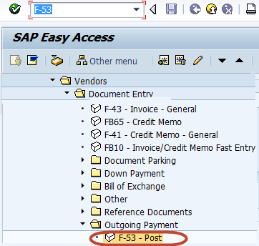](http://cdn.guru99.com/images/sap/2012/07/WithHPay011.png)

In the next screen, Enter the following data

1. Enter the Document Date
2. Enter the Cash/Bank Account the Payment is to be posted
3. Enter the Payment Amount
4. Enter the Vendor Id of the Vendor receiving the Payment

[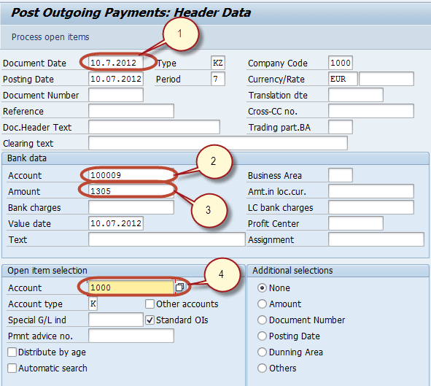](http://cdn.guru99.com/images/sap/2012/07/WithHPay02.png)

In the next screen,Assign the Payment Amount to Appropriate Invoice so as to balance the Payment with the Invoice Amount

[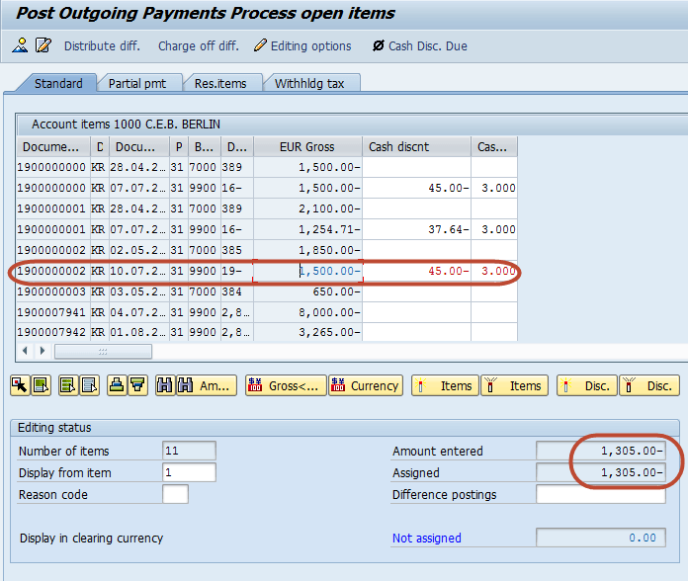](http://cdn.guru99.com/images/sap/2012/07/WithHPay03.png)

[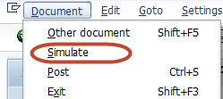](http://cdn.guru99.com/images/sap/2012/07/WithHPay04.png)

In the next screen, we can check the Withholding Tax is also Credited as per the base amount entered in the Invoice.

[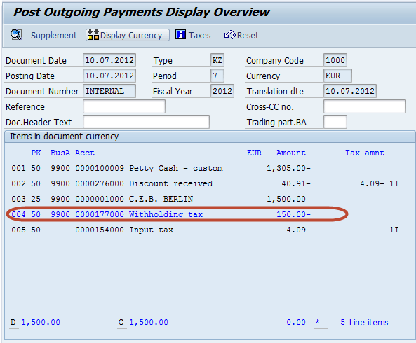](http://cdn.guru99.com/images/sap/2012/07/WithHPay05.png)

Press Post from the Standard Toolbar to post the Incoming Payment

[How to Post Withholding Tax During Payment Posting](http://cdn.guru99.com/images/sap/2012/07/WithHPay06.png)

Check for the Status bar  for the Document number to be generated

[How to Post Withholding Tax During Payment Posting](http://cdn.guru99.com/images/sap/2012/07/WithHPay07.png)